Living in a Changing World
Under 21? Out of education, work or training? Interested in film-making?
This is the opportunity you have been looking for.
The Great Debate is delighted to invite you to come and take part in Living in a Changing World, a documentary-making project delivered by, about and for young people. Here is where you can find out all you wanted to know about camera work, sound recording, lighting, and editing. Or if you fancy the limelight, why not try your hand at presenting and interviewing? This project is FREE for young people who are not in employment, education or training, so drop us a line and join in!
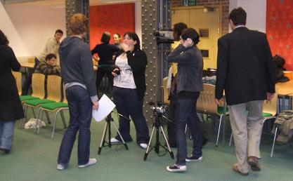
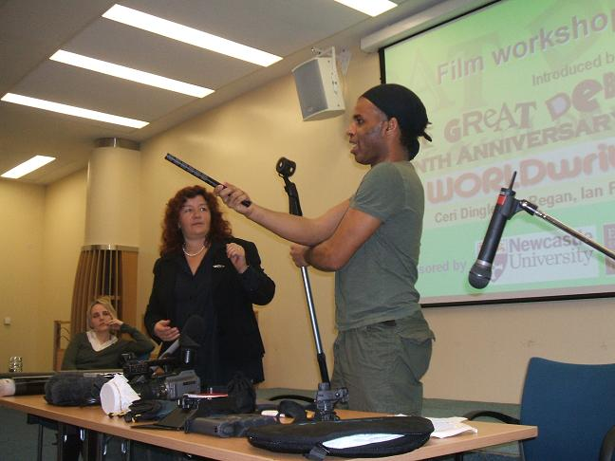
When you join the core group of young people involved in this project you will explore what you think are the issues facing you in the future. Forming a production team to create a documentary, you will be given training and guidance in sound production, lighting and camera work, interview techniques, scripting questions, storyboarding, presentation and editing. Guidance from creative media professionals will be available at each stage of the process, but both the content of the film and decision-making processes will be driven by you.
During the project you will get hands on experience of filming a one day workshop, Getting Real About Climate Change on the theme of how humanity should respond to climate change. Capturing Reality, a film-making workshop for young people will be included in Getting Real About Climate Change to facilitate wider involvement in the film beyond the core production team and encourage sharing of ideas between the Living in a Changing World team and workshop participants.
The Great Debate team aims to link participants with vocational pathways, such as apprenticeships, artist / film-making mentorship schemes with dedicated organisations, Northern Film & Media's training and development initiatives, and routes into further education.
This Mediabox project is a partnership between The Great Debate and RCE North East

